**Supplementary Information**

**Diverse lithic production strategies in southwest China during Late Middle Pleistocene**

**Authors:** Yue Hu1,2*, Ben Marwick3, Yamei Hou4,5, Weiwen Huang4,5, Bo Li2,6

**Affiliations:**

1 Department of Archaeology, School of History and Culture, Sichuan University, Chengdu 610207, China

2Centre for Archaeological Science, School of Earth and Environmental Sciences, University of Wollongong, Wollongong, NSW 2522, Australia

3Department of Anthropology, University of Washington, Seattle 98195, USA

4Key Laboratory of Vertebrate Evolution and Human Origins, Institute of Vertebrate Paleontology and Paleoanthropology, Chinese Academy of Sciences, Beijing 100044, China

5Institute of Vertebrate Paleontology and Paleoanthropology, Chinese Academy of Sciences, Beijing 100044, China

6ARC Centre of Excellence for Australian Biodiversity and Heritage, University of Wollongong, Wollongong, NSW 2522, Australia

*Correspondence to: YH (yh280@scu.edu.cn)

**Keywords:** Middle Palaeolithic, Southwest China, Guanyindong, Diversity, Levallois, Quina

# Method

## Typological and technological approach

Except when referring to the technical analysis developed by authors such as Geneste (1988), Boëda et al.(1990, 1993), Geneste et al.(1997) and Vaquero(2008), the sorting procedures we used for stone artefacts are according to the typology developed and summarized by Bordes (Bordes 1961, Bordes 1969, Debénath and Dibble 1993) and Inizan et al. (1999) . The four main categories consist of cores, flakes, tools, chunks and debris. The main categories are defined in **Table S1**. For cores, we divided them in Levallois cores, discoid cores, truncated faceted pieces, volumetric cores, and ordinary cores, which are further divided as single-platform, double-platform and multiply-platform cores, based on the quantity of platforms they have. Complete flakes were classified into ordinary flakes, Levallois flakes, débordant flakes, elongated flakes, Kombewa flakes, tablets, natural backed knife, and crests. Other flakes include flake fragments, retouched flakes and retouched flake fragments. Because retouched pieces account for a large component in the assemblage, we further classified them into side-scrapers, denticulates, notches, points, borers, burins, backed knives, end-scrapers, choppers and cleavers based on their technological and morphological characters according to Borders (Debénath and Dibble 1993). The chunks and debris are those artefacts that present artificial marks but without any retouch or served as cores or flakes.

## Metric and morphometric data

Metric and morphometric data were collected using a digital calliper and an electronic scale. Basic raw material and metric data (mainly including length, width and thickness, and mass) were measured for each artefact and different attributes for different categories were differentiated. For the chunks and debris, only their individual mass were measured.

**Table S1 | The definitions of some key categories mentioned in the chapter**

|  |  |
| --- | --- |
| **Category** | **Definition** |
| Ordinary cores | Simple flaking cores with different quantity of platforms. |
| Complete flakes | Flakes, always but not all, with platform, percussion point, bulb, completed proximal, medial and distal part. |
| Flake Fragments | Pieces lack any part of a complete flake. |
| Retouched flake (or flake fragments) | Complete flakes or flake fragments that are retouched. |
| Débordant flakes | Levallois core edge flake. The aim of removal of this flake is to maintain the lateral convexity of the Levallois core (Boëda, Geneste et al. 1990). |
| Elongated flakes | Flakes are relatively long (length ≥ 2×width). |
| Tablets | A flake with its exterior surface as its core’s entire original platform surface, and facets on its margins that are portions of previous flake scars of the core(Debénath and Dibble 1993). |
| Natural backed knife | A flake with a cortex abrupt edge opposite a natural sharp cutting edge. |
| Crests | A flake to initialize a production of blades through bifacial flaking along one edge of a nodule (Debénath and Dibble 1993). |
| Chunks and debris | Artefacts that present artificial marks but without any retouch or served as cores or flakes. |

### Raw materials

The classification of raw materials is based on their physical properties, including homogeneity, crystal structure, grain size, etc. Sub-division was not conducted because their fracture properties are similar within a category (e.g., chert and limestone).

### Cores

For cores, the following information was collected: type, geometry (column, conic, cubic, irregular, circular and wedged), maximum dimension, medial width, distal width, distal thickness, platform types, platform width, platform thickness, scar number, scar length, cortex percentage, cortex texture, cortex location, heat damage, platform preparation, and rotations (see **Figure S1** for examples of the variables). Types comprise Levallois, discoid, volumetric cores, truncated faceted pieces, single, double, and multiply platform cores. Only large and main scars (> 2 cm) were counted. Cortex percentage is estimated with ~10% uncertainty and cortex textures are mainly rough, smooth and tabular. Platform preparation chiefly consists of plain, faceted, cortex. The rotation number indicates possible platform transform times during the reduction of a core.

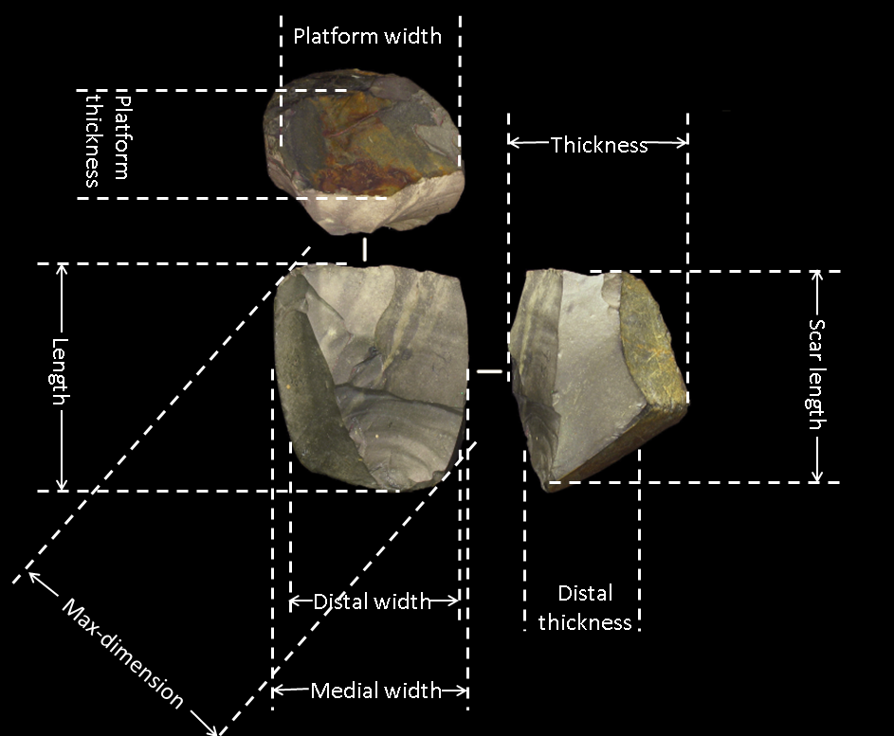

**Figure S1 | Key morphometric variables of cores.**

### Flakes

For flakes, we recorded their types (including complete, fragment, retouched or sub-types such as Levallois and débordant), maximum dimension, length, oriented width, width at 25%, 50% and 75% max dimension, oriented thickness, thickness at 25%, 50% and 75% max dimension, platform width, platform thickness, platform shape (triangle, rectangle, quadrangle, gull-wing, fusiform, trapezoid and irregular), dorsal scar number (i.e., the completed flake scars left on the dorsal surface), dorsal scar directions, cortex percentage, cortex texture (rough, smooth, angular), cortex location (platform, proximal, medial and distal), heat and damage, termination , and platform preparation (plain, faceted, cortex, dihederal, focus and missing). Key morphometric terms are demonstrated in **Figure S2** and **Figure S3**.

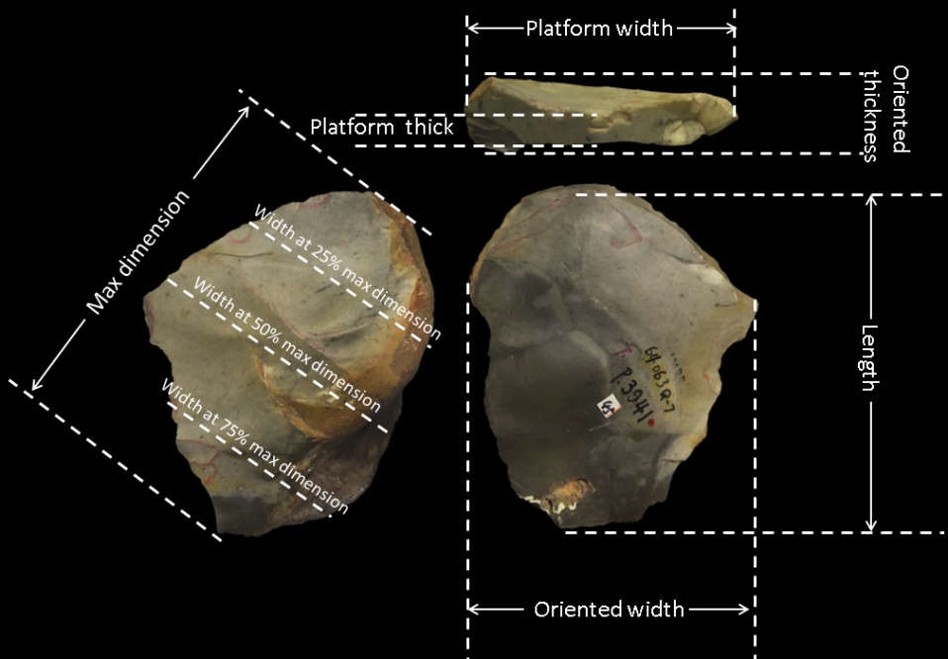

**Figure S2 | Schematic model showing key morphometric variables of flakes.**

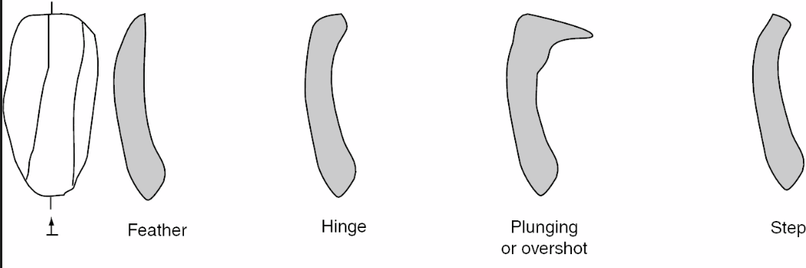

**Figure S3 | Flake termination types (from Shea, 2013)**

### Retouched pieces

For retouched pieces, attributes including number of layers, number of edges, edge types, number of burins, retouch diameter (for curvature), retouch depth (for curvature), notch number, notch location, notch length and depth, edge angle, GUIR and index of invasiveness were recorded. The number of layers were estimated by the overlaps of retouching phases. Edge types include straight (i.e., the edge shape is straight), convex (i.e., the edge shape is convex), concave (i.e., the edge shape is concave), denticulate (i.e., the edge shape is denticulate), end (end-scraper), beak, pointed (borer), and notch. The edge angle was calculated by measuring the width at the 3 mm depth of the edge and then transfer the value into angle degree (Eren and Lycett 2016). To estimate the invasion and intensity of retouching, two concepts “Index of Invasiveness” (Clarkson 2002) and “Geometric Index of Unifacial Reduction (GIUR)” were applied (Kuhn 1990, Hiscock and Clarkson 2005, Hiscock and Tabrett 2010).

## **Data collection method**

Data were recorded in Excel spreadsheets. Statistical analysis, interaction patterns among categories and attributes, tables and charts were computed using R and RStudio. The R code used to produce the statistics and graphs presented in this thesis are openly available online at https://doi.org/10.17605/OSF.IO/7B5QD

# Raw materials

The raw materials of the assemblage are dominated by chert (77.3%) followed by limestone (21.4%) and basalt (0.9%). Other materials (such as sandstone and quartz) were only rarely used (0.4%) (**Table S2**). The dominant exploitation of chert for core reduction and tool manufacture suggests that the Guanyindong hominins deliberately selected chert as the raw material, being aware that chert is comparatively isotropic and fine-grained, allowing them to have a closer control over artefact production. The majority of raw materials are accessible within 6 km of the site (Leng 2001, Li, Hou et al. 2009). Specifically, chert is available within about 2–6 km, while limestone and volcanic rocks (such as basalt and quartz) are all available from local mountains, river bed and exposed sediments. In Middle Pleistocene Europe most lithic materials were obtained from nearby sources (< 5 km) or relatively close localities (5–20 km), and sources beyond 20 km are rare (Fernandes, Raynal et al. 2008). The distance between the site and main raw material source indicates that the Guanyindong tool-makers have been foraging for tool-stone over landscape ranges consistent in size with other Middle Pleistocene population.

**Table S2 | Stone artefact types and percentage of raw materials of Guanyindong site. The proportions are shown in the brackets following numbers.**

|  |  |  |  |  |
| --- | --- | --- | --- | --- |
|  | **chert** | **limestone** | **basalt** | **other** |
| **cores** | 208 (83.9%) | 2 (0.8%) | 38 (15.3%) | 0 (0%) |
| **complete flake** | 141 (74.6%) | 0 (0%) | 46 (24.3%) | 2 (1.1%) |
| **flake breaks** | 6 (100%) | 0 (0%) | 0 (0%) | 0 (0%) |
| **debris** | 569 (74%) | 8 (1%) | 190 (24.7%) | 2 (0.3%) |
| **retouched chunks** | 43 (76.8%) | 0 (0%) | 13 (23.2%) | 0 (0%) |
| **retouched flakes and breaks** | 736 (78%) | 10 (1.1%) | 192 (20.4%) | 5 (0.5%) |
| backed knife | 5 (71.4%) | 0 (0%) | 2 (28.6%) | 0 (0%) |
| bec | 6 (85.7%) | 0 (0%) | 1 (14.3%) | 0 (0%) |
| borer | 47 (73.4%) | 0 (0%) | 17 (26.6%) | 0 (0%) |
| bur | 5 (83.3%) | 0 (0%) | 1 (16.7%) | 0 (0%) |
| chopper | 1 (50%) | 1 (50%) | 0 (0%) | 0 (0%) |
| cleaver | 1 (100%) | 0 (0%) | 0 (0%) | 0 (0%) |
| denticulate | 53 (69.7%) | 1 (1.3%) | 21 (27.6%) | 1 (1.3%) |
| endscraper | 30 (83.3%) | 0 (0%) | 6 (16.7%) | 0 (0%) |
| natural backed | 3 (60%) | 0 (0%) | 2 (40%) | 0 (0%) |
| notch | 68 (86.1%) | 1 (1.3%) | 10 (12.7%) | 0 (0%) |
| point | 23 (82.1%) | 0 (0%) | 5 (17.9%) | 0 (0%) |
| scraper | 464 (77.5%) | 7 (1.2%) | 124 (20.7%) | 4 (0.7%) |
| tanged point | 8 (88.9%) | 0 (0%) | 1 (11.1%) | 0 (0%) |
| unidentifiable | 22 (91.7%) | 0 (0%) | 2 (8.3%) | 0 (0%) |
| **overall** | 1703 (77%) | 20 (0.9%) | 479 (21.7%) | 3 (0.4%) |

# Core reduction

The basic attributes of 248 cores are summarised in **Table S3** (see examples in **Figure S4**). The median maximum dimension of them is 72 mm. The median dimension is 43.5x55x47 mm (L*W*Th). The median weight of the cores is 149.5 g. Chert dominates the raw material of cores (85%). Various geometries of cores were identified, including irregular (80.5%), conic (9.8%), column (6.7%) and small amounts of wedged and circular (~3%). Three types of cores can be identified according to the number of platforms (**Figure S5a**), single platform (60.5%), double platform (27.2%) and multiple platform (11.7%). Most pieces are ordinary cores, integrated with truncated faceted pieces (n=60; 24%), volumetric cores (n=12; 5%), discoid cores (n=10; 4%), Levallois cores (n=11; 4%), Kombewa cores (n=10; 4%), and a small number of other types (i.e. bifacial core, hemispheric core). The majority (~80%) of cores have 1–4 flake scars, and some (16%) have 5–7 scars and only a small quantity (4%) have more than 7 scars (**Figure S5b**). The distribution of length of the flake scars on cores is shown in **Figure S5c**. The median length of scar is 26 mm.

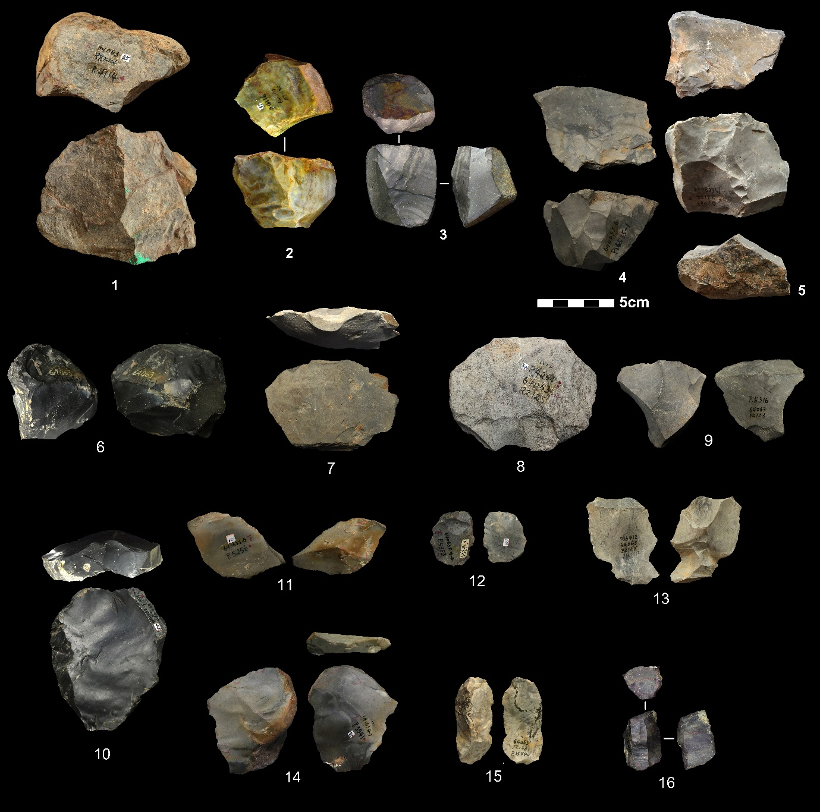

**Figure S4 | Photos showing selected cores and flakes.** 1-2, 4, single platform cores; 3,5, double platform cores; 6, discoid cores; 8, truncated faceted; 7, 9-14, flakes; 15, crest flake; 16, volumetric core.

**Table S3 | Summary of mean, standard deviation (SD), coefficient of variation (CV), quantile values at 25%, 50% and 75% for basic core attributes.**

|  | **Length (mm)** | **maximum dimension (mm)** | **medial width (mm)** | **distal width (mm)** | **thickness (mm)** | **distal thickness (mm)** | **mass (g)** | **platform** | **platform width (mm)** | **platform thickness (mm)** | **scar number** | **cortex percentage (%)** |
| --- | --- | --- | --- | --- | --- | --- | --- | --- | --- | --- | --- | --- |
| **mean** | 47.2 | 75.1 | 58.0 | 49.2 | 51.8 | 38.7 | 198.9 | 1.5 | 50.9 | 43.7 | 2.9 | 14.5 |  |
| **SD** | 20.2 | 21.6 | 21.2 | 21.5 | 29.6 | 17.1 | 166.8 | 0.8 | 20.0 | 19.8 | 2.0 | 19.4 |  |
| **CV** | 0.4 | 0.3 | 0.4 | 0.4 | 0.6 | 0.4 | 0.8 | 0.5 | 0.4 | 0.5 | 0.7 | 1.3 |  |
| **25%** | 33.0 | 63.0 | 43.0 | 35.2 | 38.2 | 27.2 | 100.2 | 1.0 | 37.0 | 30.2 | 1.2 | 0.0 |  |
| **50%** | 43.5 | 72.0 | 55.0 | 45.0 | 47.0 | 37.0 | 149.5 | 1.0 | 50.0 | 40.0 | 2.0 | 7.5 |  |
| **75%** | 57.8 | 83.8 | 68.0 | 60.6 | 60.8 | 48.0 | 243.0 | 2.0 | 61.8 | 51.9 | 4.0 | 20.0 |  |

Most cores (78%) are covered with zero or a low percentage (< 25%) of cortex (**Figure S5d**). The cortex locations are always on platforms and bottoms. The majority of platform types are plain (54%), followed by facetted platforms (18.2%) (**Figure S5e**). Most cores (83%) have one or two rotations, which means that the was rotated core one to two times during flake removals (**Figure S5f**) to find a new platform to keep flaking when current platform and the original platform is no longer suitable for further striking. About 10% of the cores have three or more rotations.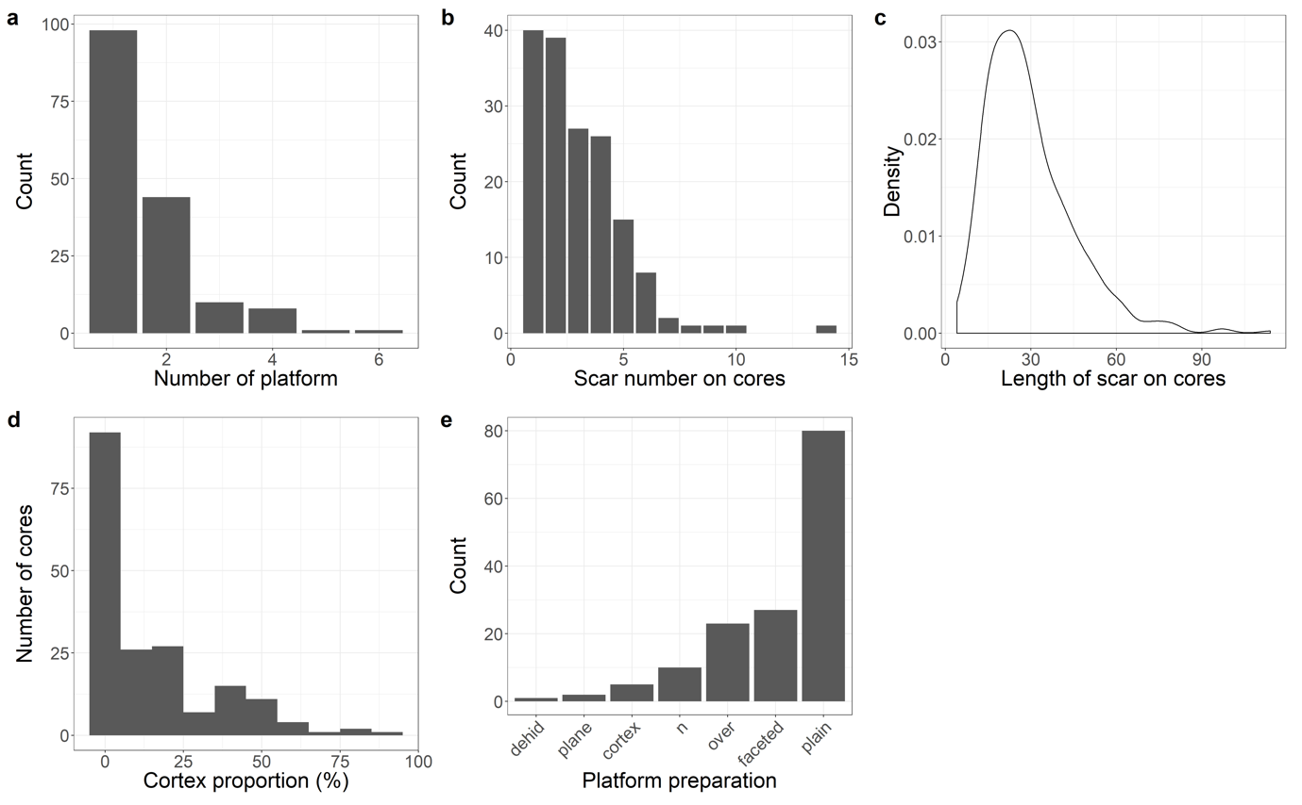

**Figure S5 | Statistical results of cores.** (a, b, d, e) Histograms showing the number of cores with different number of platforms, scar number, cortex proportion and platform types. (c) Density distribution of the scar length on cores.

There are also 12 cores that produced elongated flakes. Those cores were manufactured on various blanks such like chunks, nodular and flake. Direct hard hammer percussion is the technique that reduced cores. The median max dimension of the cores is 52.4 mm. Most of cores do not have cortex remained and the median number of scars left is 4. The morphologies of the cores are various, including irregular, column, wedged and cubic. Prepared and plain platforms dominate the core platform types. The cores are only minimally prepared, and the volume is not thoroughly shaped out before starting the production, thus showing significant variation in shape and size. For example, the geometries of these cores vary from circle to cylinder.

Many cores were exploited from large flakes, of which four patterns are observed based on the directions of knapping, unidirectional and bidirectional (**Figure S6**). Those cores are primarily knapped along the periphery of the flake, using the natural slab morphology of a flake as platform and volumetric consumption.

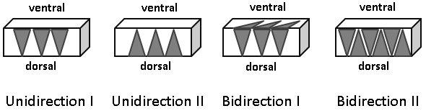

**Figure S6 | Flake core patterns.** The gray triangles indicate the direction of flake scars. Unidirection I and II means flake scars only come from one direction. Bidirection I and II means flake scars come from different directions.

# Flakes

Among the 1,138 flake pieces studied (see **Figure S4** for selected specimens), there are 189 complete flakes, 214 retouched flakes, 6 flake breaks and 729 retouched flake breaks. The flaking technique is mainly free hand percussion with hard hammer. A number of retouched flakes show parallel or sub parallel retouch scars, probably resulting from pressure flaking techniques (Dibble 1994).

Table 3 summarises basic flake attributes. The median dimensions of complete flakes are 48x49x16 mm; this is larger than that of scars remained on the cores, suggesting that many of the flakes were obtained outside of the cave, or that the cores that produced them were removed from the assemblage. The majority of flakes have masses from 10 to 100 g (**Figure S7a**) and maximum dimensions from 20 to 80 mm (**Figure S7b**). The median maximum dimension of flakes pieces is ~60 mm. The median of the ratios of length and oriented thickness is 3 and more than 86% of the ratios are greater than 2, suggesting that the flakes are relatively thin and indicating a capability of a high degree of knapping control (**Figure S7c**). **Figure S7d** and **S7e** show the thickness and width at 25%, 50% and 75% of maximum dimension, respectively. Both the thickness and width at 50 % of maximum dimension are systematically and slightly larger than those at the other parts. This also suggests a high degree of control over the morphology of flakes.

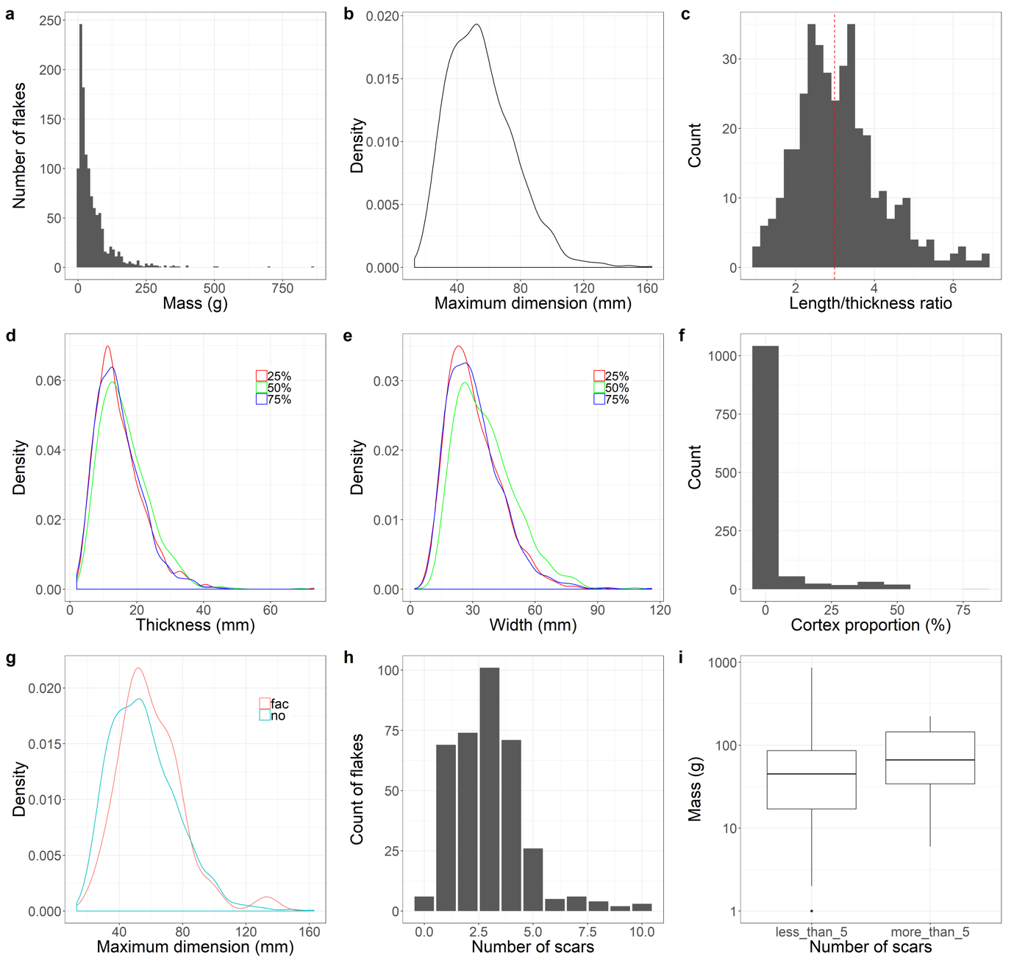

**Figure S7 | Statistical results for flakes.** (a, c, f and h) The counts of flakes for different mass, different length/thickness ratios, cortex proportion and number of dorsal scars. (b, d, and e) Density distribution of flakes for different maximum dimension, thickness, and width. (g) Comparison of density distributions of flakes with and without faceted platforms. (i) Box plots showing the mass difference between flakes with different scar numbers.

More than 80% of the flakes (including retouched flakes) have no cortex (**Figure S7f**). The cortex proportion of those flakes with cortex is mainly restricted from 5 to 10%. It suggests that most of flakes were introduced into the assemblage at later stages of reduction. It is likely that hominins took secondary products into the cave after they initially knapped the blank outside.

There are 396 artifacts that have distinguishable platforms, these can be divided into cortical (n=36; 9.1%), plain (n=212; 53.5 %), faceted (n=43; 10.9%), dihederal (n=45; 11.4%) and focus (n=20; 5.1%). Although the plain and cortical platforms make up the largest proportion, flakes with prepared platforms are frequent, indicating a predetermined strategy during core reduction. Flakes with faceted platforms are systematically larger than other platform types (**Figure S7g**), indicating that hominins prepared flake platforms as part of a strategy to produce larger flakes .

The median dorsal scar number is three (**Table S4**) and flakes with three dorsal scars also account for the largest proportion (**Figure S7h**). Flakes with more than five scars are rare. As expected, flakes with more than five scars are systematically larger than those flakes with fewer scars, because the flake scars are fairly constant in size across the assemblage (**Figure S7i**).

The median dimension of flake platforms is 31x12 mm (**Figure S8a**). Flake platform shapes include triangular (n=136; 44%), quadrangular (n=87; 28%), fusiform (n=46; 15%), and gull-wing (n=31; 10%) and with a small number of trapezoid, rectangle and irregular (**Figure S8b**). In order to test the possible relationships between platform shapes and flake dimension, the maximum dimension as well as thickness at 50 % of maximum dimension for different platform shapes was compared (**Figure S8c** and **S8d**). We found that flakes with gull wing and fusiform platforms are slightly thinner (more concentrated around 10–15 mm), and those with triangular platforms are the thickest (around 20 mm). Similar patterns are observed for the maximum dimension, i.e., triangular platforms are more frequently found on larger flakes.

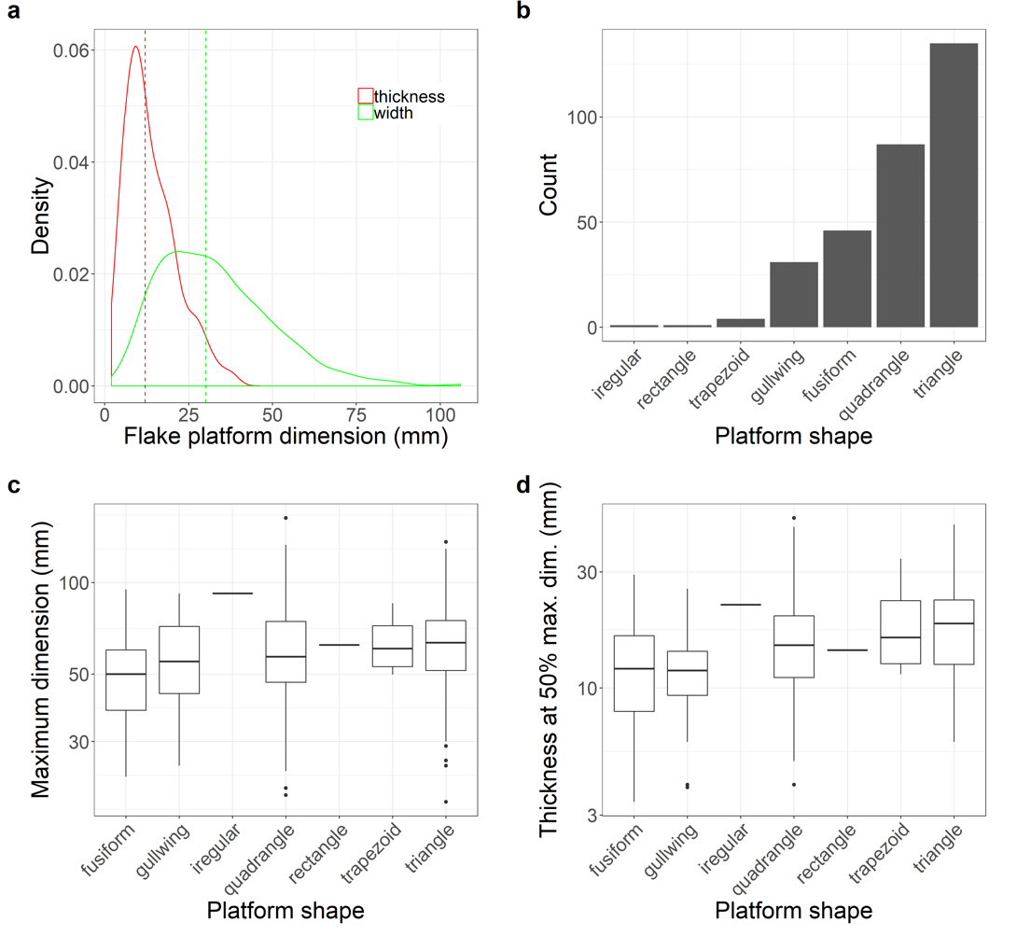

**Figure S8 | Statistical results for flake platforms.** (a) Density distribution of flakes’ platform thickness and width. (b) Number of flakes with different platform shapes. (c) Box plots showing the maximum dimension of flakes with different platform shapes. (d) Box plots showing thickness at 50% maximum dimension of flakes with different platform shapes.

The directions of dorsal scars from 356 flakes were recorded. We divided the directions into 8 sections (**Figure S9a**). Except for 85 scars that we could not orient, the number of dorsal scars in each direction were recorded. Among them, 221 flakes have dorsal scars that have the same directions of the flake’s percussion axis. The other major directions are from directions 2, 3 and 8 (marked in the gray semi-circle) suggesting that most of the previous flakes on original cores have similar directions of the final scar. In other words, rotation of the core was not frequent.

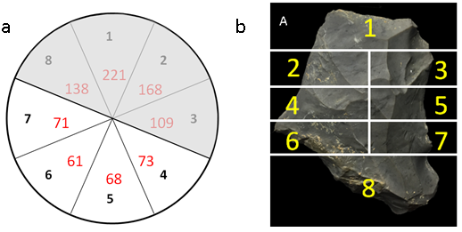

**Figure S9 | Dorsal scar directions and zone of a tool.** (a) Sketch showing the dorsal scar directions of flakes. The numbers in black are directions showing the scar directions (e.g. ‘1’ from platform; ‘3’ from right lateral; ‘5’ from distal; ‘7’ from left lateral). The numbers in red are the counts of dorsal scars that come from this direction. The gray area marks the most frequent dorsal scar directions. (b) Division of 8 sections on a tool.

Besides, there were 14 elongated were found including 11 elongated flakes, 3 crest flakes. The median maximum dimension of them is about 74 mm and their platforms are mainly plain.

**Table S4 | Summary of mean, standard deviation (SD), coefficient of variation (CV), quantile values at 25%, 50% and 75% for basic flake attributes.**

|  |  |  |  | **length (mm)** | **maximum dimension (mm)** | **oriented width (mm)** | **width at 25% maximum dimension (mm)** | **width at 50% maximum dimension (mm)** | **width at 75% maximum dimension (mm)** | **oriented thickness (mm)** | **thickness at 25% maximum dimension (mm)** | **thickness at 50% maximum dimension (mm)** | **thickness at 75% maximum dimension (mm)** | **mass (g)** | **platform width** | **platform thickness (mm)** | **scar number** | **cortex percentage (%)** |
| --- | --- | --- | --- | --- | --- | --- | --- | --- | --- | --- | --- | --- | --- | --- | --- | --- | --- | --- |
|  |  |  | **mean** | 49.4 | 62.5 | 50.3 | 36.3 | 41.9 | 35.2 | 17.6 | 16.1 | 16.6 | 13.7 | 68.2 | 32.8 | 13.7 | 2.9 | 9.4 |  |
|  |  |  | **SD** | 19.2 | 22.5 | 19.2 | 14.1 | 15.3 | 14.8 | 8.1 | 7.6 | 7.8 | 6.8 | 81.7 | 16.8 | 7.8 | 1.6 | 15.1 |  |
|  |  |  | **CV** | 0.4 | 0.4 | 0.4 | 0.4 | 0.4 | 0.4 | 0.5 | 0.5 | 0.5 | 0.5 | 1.2 | 0.5 | 0.6 | 0.6 | 1.6 |  |
|  |  |  | **25%** | 35.0 | 48.2 | 36.0 | 26.0 | 30.1 | 25.0 | 11.8 | 10.9 | 11.0 | 9.0 | 18.8 | 19.9 | 8.0 | 2.0 | 0.0 |  |
|  |  |  | **50%** | 48.0 | 60.0 | 49.0 | 35.0 | 41.0 | 34.0 | 16.0 | 15.0 | 15.0 | 12.6 | 45.5 | 30.9 | 12.0 | 3.0 | 0.0 |  |
|  |  |  | **75%** | 60.8 | 76.0 | 61.7 | 44.9 | 51.1 | 43.0 | 23.0 | 20.9 | 21.0 | 18.0 | 90.0 | 43.0 | 18.3 | 4.0 | 10.0 |  |

# Retouch technologies

A total of 999 retouched pieces were found in the assemblage, accounting to 48.5% of lithic assemblage (see examples from **Figure S10**). The median maximum dimension is 54.1 mm. The max dimensions and masses of retouched flake are generally smaller than unretouched flakes, suggesting that they probably come from the same reduction sequence (**Figure S11a**).

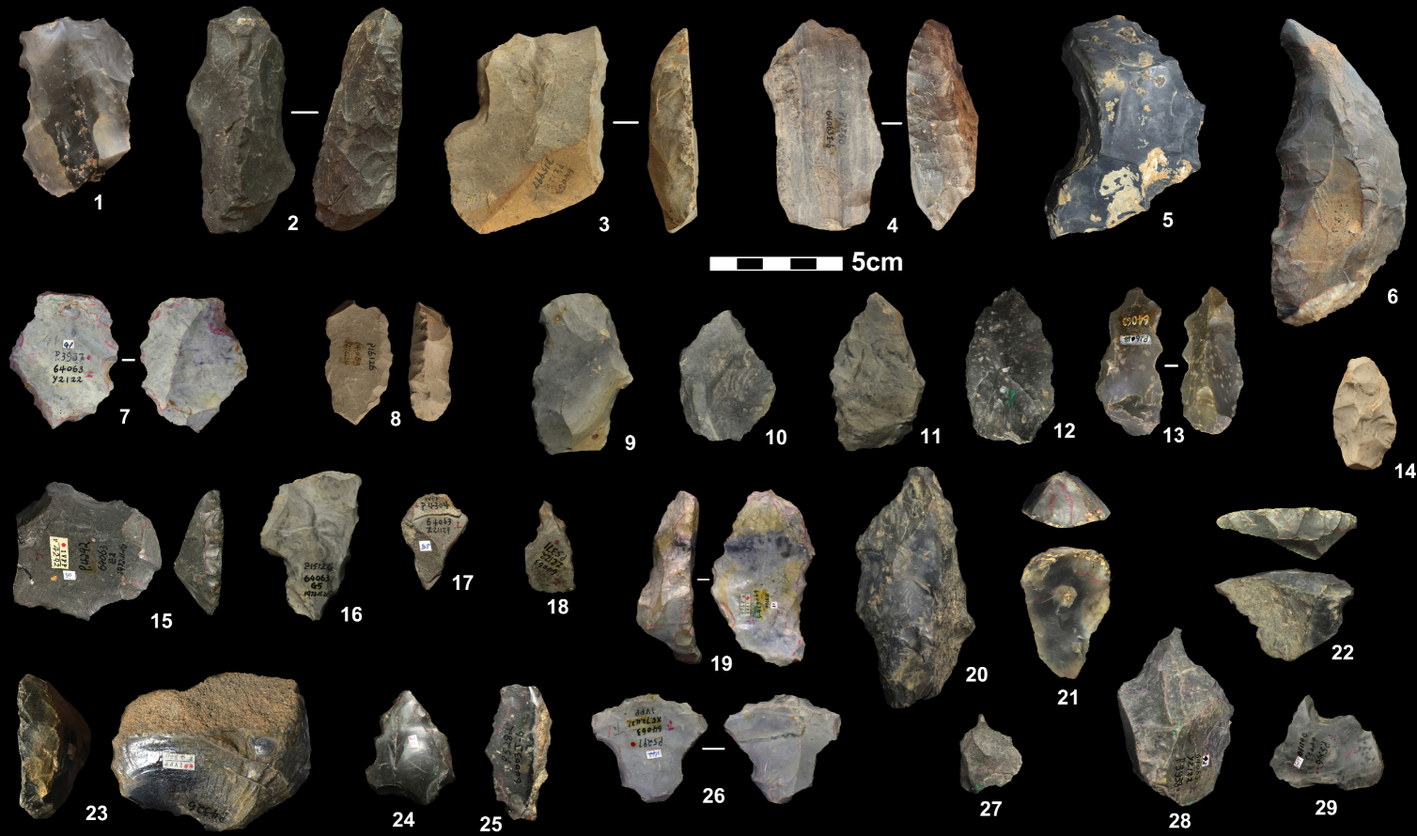

**Figure S10 | Selected retouched pieces.** 1, 7, 9, 13 and 26, denticulates; 2-6, 8, 10-12, 14, 15 and 19, scrapers; 16, notch; 17 and 24, point; 18, 27-29, borers; 20, 25, natural backed knives; 21, 23 end scrapers; 22, transverse scrapers;

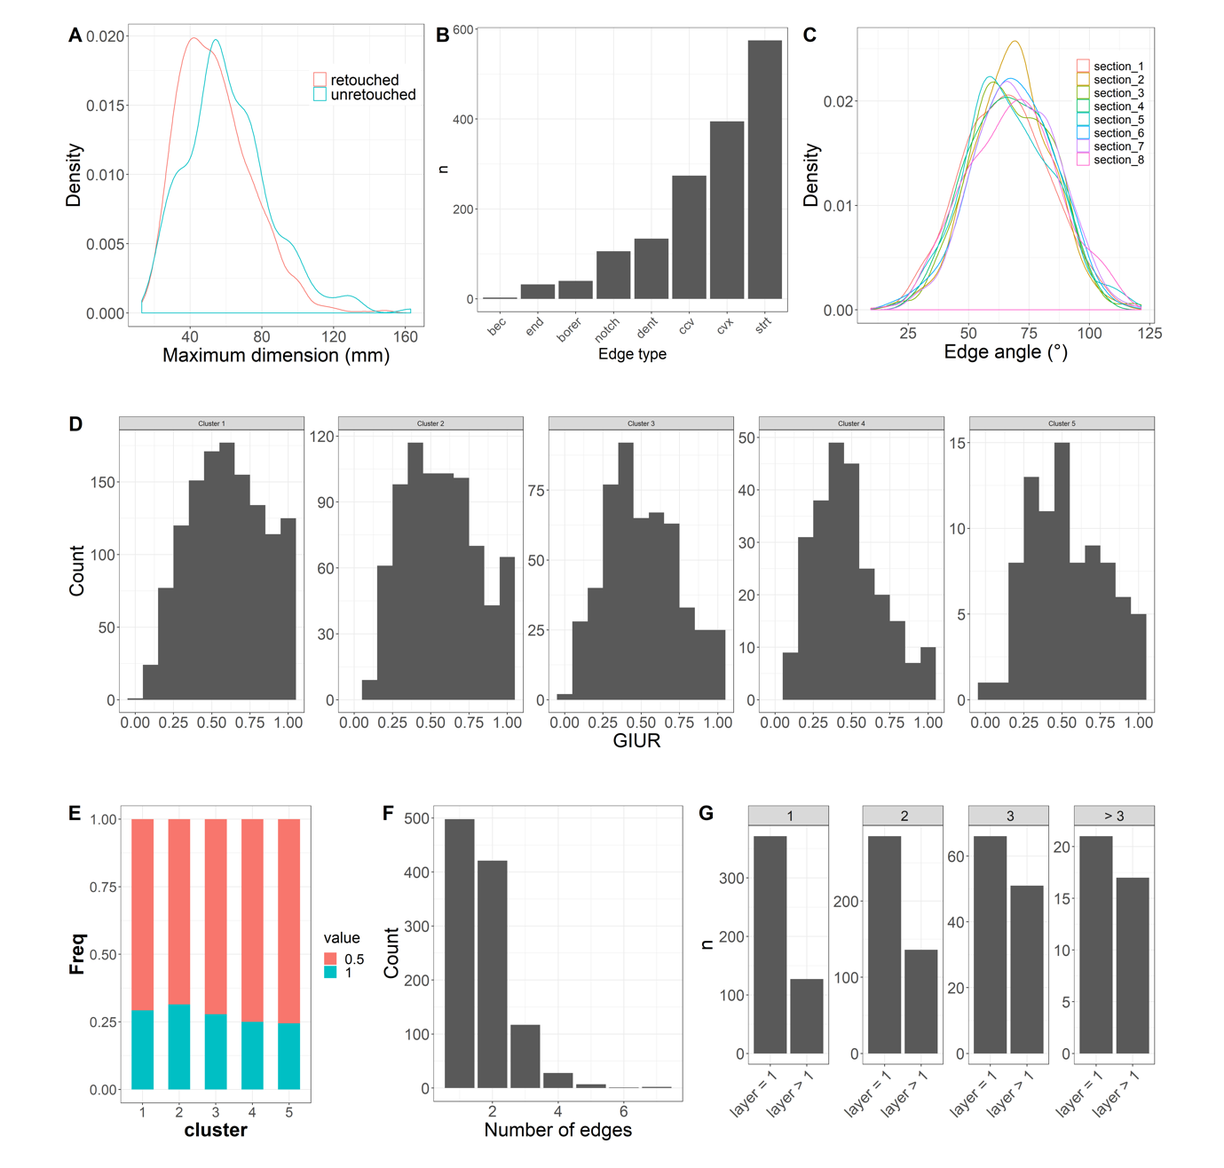

**Figure S11 | Statistical results for flake platforms.** (a) Comparison of the density distribution of the maximum dimension between retouched and unretouched flakes. (b) Histogram showing the counts of tools for different edge types. (c) Comparison of edge angles among different sections. (d) Comparison of distribution of GIUR among 5 groups of flakes with different masses. (e) Invasiveness Index if the 5 mass groups of flakes. (f) Histogram showing the counts of tools of different number of edges. (g) The counts of tools that have one and more than one retouching layers for tool with different edge number (1,2,3 and >3).

Most retouched pieces are made on flakes breaks (~70%) and complete flakes (~20%), a small number of them are made on either chunks or pebbles. Side scrapers and denticulates dominate retouched pieces (65%), followed by borers (6%) and other types (**Table S2**).

The locations and shapes of retouch and the properties of the retouching scars provide further insight into tool manufacturing and management. Among the 1,559 retouched edges that we recorded (**Figure S11b**) , straight edges constitute the largest proportion (n=575) followed by convex (n=395) and concave edges (n=248). We calculated the edge angles on eight sections from a tool using the method in Eren and Lycett (2016) (see **Figure S9b**).

In **Figure S11c** we see that the angles of sections 1 to 8 are similar, mainly between 50° and 80°. The median angle of all edges is 67°. This suggests that the edge angles of the entire blank were indiscriminately retouched, and relatively steeply. More than half of all retouched pieces were retouched on two or more edges. Those data suggest extensive exploitation of blanks, probably resulting from repeated episodes of recycling and resharpening.

We used two indices, the index of invasiveness (Clarkson 2002) and the Geometric Index of Unifacial Reduction (GIUR) (Kuhn 1990, Hiscock and Clarkson 2005, Hiscock and Tabrett 2010) to estimate the intensity of retouch. Most specimens were extensively retouched, i.e., more than 67% have a GIUR value greater than 0.9. In order to investigate whether smaller pieces were more intensively retouched than larger pieces, we divided the flakes into five clusters of sizes based on a dynamic programming algorithm for optimal one-dimensional k-means clustering, which selects optimal number of clusters of flake sizes based on the Gaussian mixture model using the Bayesian information criterion (BIC) (see Hu et al. (2019) for details). **Figure S11d** and **S11e** shows the GIUR and Index of Invasiveness distributions according to different size groups. It shows that the smaller tools tend to have higher GIUR values (**Figure S11d**). This is consistent with our prediction that small artefact sizes are a result of more extensive retouch and reuse. For the Index of Invasiveness, about 75% of retouching scars did not pass half depth of each zone (**Figure S11e**). This is because the edges of most artefacts are too steep to allow the retouching scar to extend beyond half the depth of the zone. Over half of tools have more than one retouched edge (**Figure S11f**; the edges are separated by an unretouched gap between each single retouch section). And as the number increased, the number of edges that have more than one retouched layer increases (**Figure S11g**). They suggest that the tools are heavily recycled and the Guanyindong knappers were not only inclined to resharpen the edges with secondary retouch at the same location, but also attempted to create new edges when reusing their tools.

For notched (n=79) pieces, the median depth and length is 3.7 and 11.6mm. The majority of notch is Clactonian notches (65%). Ordinary notches only account for 32%. The rest of notches contain both Clactonian and ordinary notches. The location of retouching is mainly on one side which defined as longer geometric side of the piece.

# References

Boëda, E. (1993). "Le débitage discoïde et le débitage Levallois récurrent centripède." Bulletin de la Société préhistorique française **90**: 392-404.

Boëda, E., J.-M. Geneste and M. L (1990). "Identification de chaînes opératoires lithiques du Paléolithique ancien et moyen." Paléo **2**: 43-80.

Bordes, F. (1961). Typologie du Paléolithique Ancien et Moyen. Paris, Centre National de la Recherche Scientifique.

Bordes, F. (1969). "Reflections on typology and techniques in the Paleolithic." Arctic Anthropology **6**: 1-29.

Clarkson, C. (2002). "An Index of Invasiveness for the Measurement of Unifacial and Bifacial Retouch: A Theoretical, Experimental and Archaeological Verification." Journal of Archaeological Science **29**(1): 65-75.

Debénath, A. and H. L. Dibble (1993). Handbook of Paleolithic Typology: Lower and Middle Paleolithic of Europe. Philadelphia, University of Pennsylvania Press.

Dibble, A. D. a. H. L. (1994). Handbook of Paleolithic Typology: Lower and Middle Paleolithic of Europe. Philadelphia, University of Pennsylvania.

Eren, M. I. and S. J. Lycett (2016). "A Statistical Examination of Flake Edge Angles Produced During Experimental Lineal Levallois Reductions and Consideration of Their Functional Implications." Journal of Archaeological Method and Theory **23**(1): 379-398.

Eric Boëda, J.-M. G., Liliane Meignen (1990). "Identification de chaînes opératoires lithiques du Paléolithique ancien et moyen." Paléo **2**: 43-80.

Fernandes, P., J.-P. Raynal and M.-H. Moncel (2008). Middle Palaeolithic Raw Material Gathering Territories and Human Mobility in the Southern Massif central, France: First results from a petro-archaeological study on flint.

Geneste, J.-M. (1988). Systèmes d’approvisionnement en matières premières au Paléolithique moyen et au Paléolithique supérieur en Aquitaine. L’Homme de Néandertal. M. Otte. La Mutation. **8:** 61-70.

Geneste, J.-M., J. Jaubert, M. Lenoir, L. Meignen and A. Turq (1997). "Approche technologique des Moustériens charentiens du sud-ouest de la France et du Languedoc oriental." Paleo **9**: 101-142.

Hiscock, P. and C. Clarkson (2005). "Experimental evaluation of Kuhn's geometric index of reduction and the flat-flake problem." Journal of Archaeological Science **32**(7): 1015-1022.

Hiscock, P. and A. Tabrett (2010). "Generalization, inference and the quantification of lithic reduction." World Archaeology **42**(4): 545-561.

Hu, Y., B. Marwick, J.-F. Zhang, X. Rui, Y.-M. Hou, J.-P. Yue, W.-R. Chen, W.-W. Huang and B. Li (2019). "Late Middle Pleistocene Levallois stone-tool technology in southwest China." Nature **565**(7737): 82-85.

Inizan, M. L., M. Reduron-Ballinger, H. Roche and J. Tixier (1999). Technology and Terminology of Knapped Stone.

Kuhn, S. L. (1990). "A geometric index of reduction for unifacial stone tools." Journal of Archaeological Science **17**(5): 581-593.

Leng, J. (2001). Early Paleolithic technology in Eastern and Southern Asia / Jian Leng. Oxford :, J. and E. Hedges : Archaeopress.

Li, Y. H., Y. M. Hou and E. Boëda (2009). "Mode of débitage and technical cognition of hominids at the Guanyindong site." Chinese Science Bulletin **54**(21): 3864-3871.

Vaquero, M. (2008). "The history of stones: behavioural inferences and temporal resolution of an archaeological assemblage from the Middle Palaeolithic." Journal of Archaeological Science **35**(12): 3178-3185.